**Date: 12/04/2024**

**Assignment**

**1.Create a database “college”.**



**2. Create a table ‘student’ with columns (id, name, date of birth, gender,branch, section, year, address) under the “college” database.**

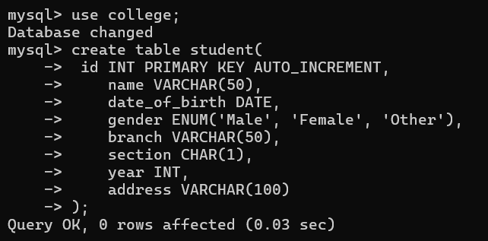

**3. Insert 10 rows into the table.**

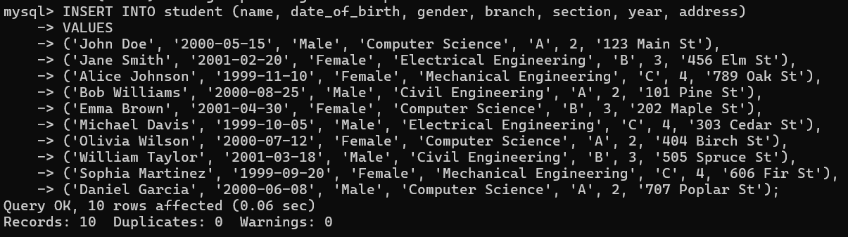

**4. Create a user with username: ‘admin’ and password: ‘admin@123’ with all the permissions like select, create, alter, drop, truncate, insert, update, and delete.**





**5. Create user username: ‘principal’ and password: ‘principal@123’ with select, insert,**

**update, and delete permissions.**

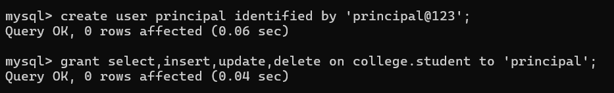

**6. Create user username: ‘faculty’ and password: ‘faculty@123’ with select and update permissions.**

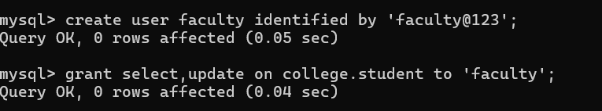

**7. Create user username: ‘student’ without a password and with select permission only.**

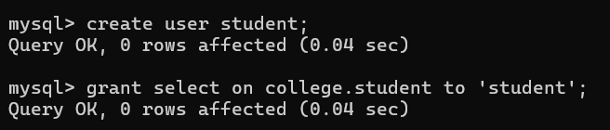

**8. Login with the ‘admin’ user and add a new column phone number.**

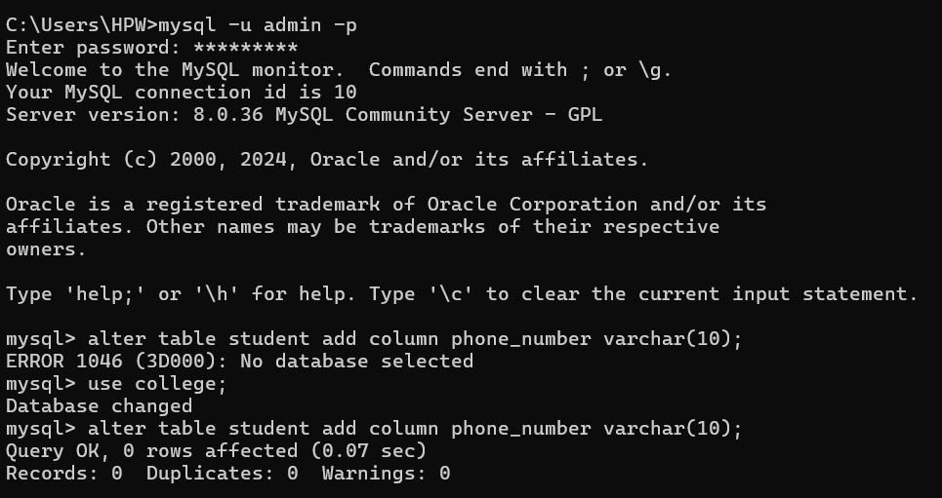

**9. Login with the ‘principal’ user and add 5 more new rows to the table with all**

**column values including phone numbers.**



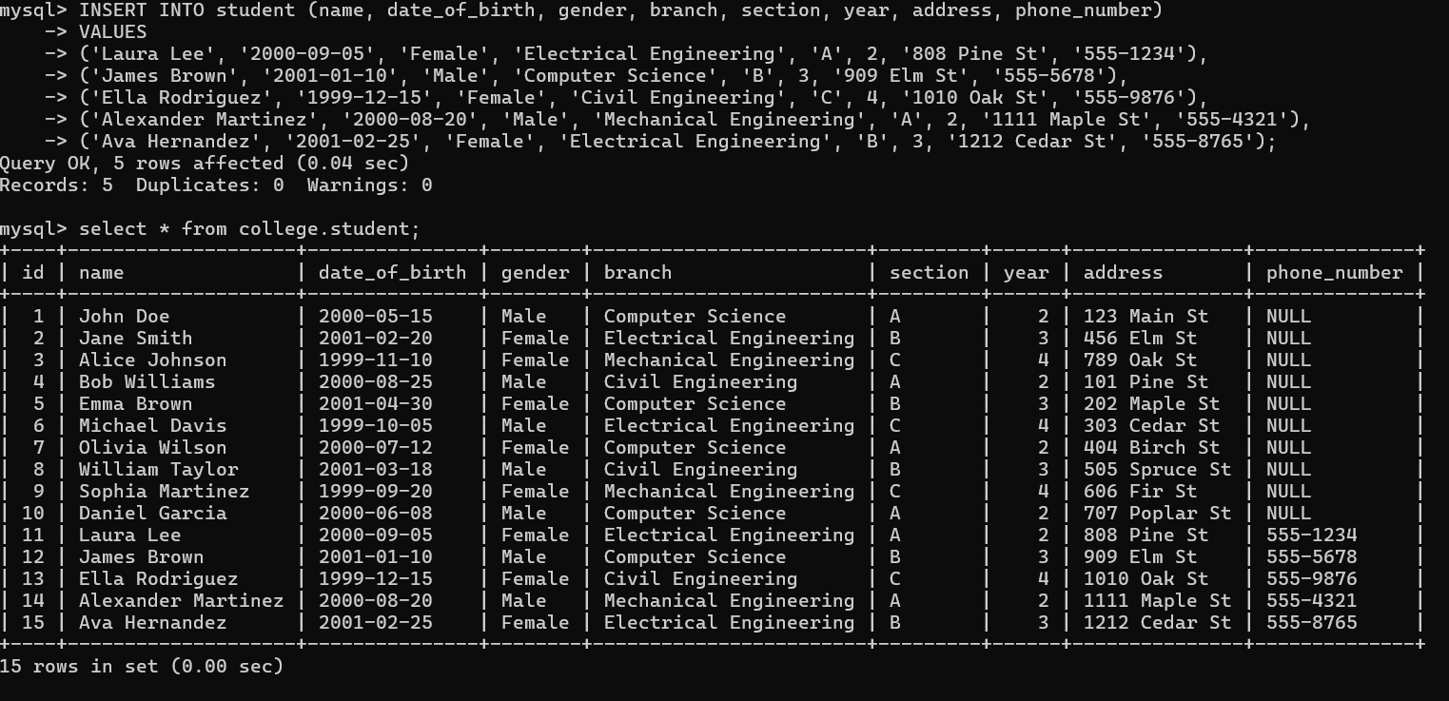

**10. Login with the ‘faculty’ user and update all the 10 students phone numbers.**

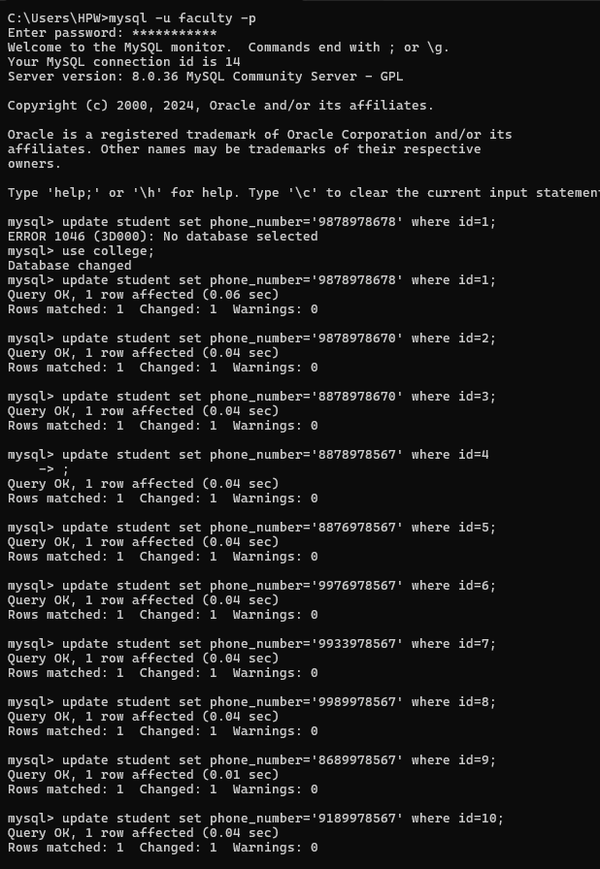

**11. Login with the ‘student’ user and display the following outputs:**

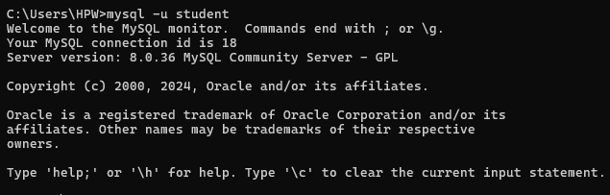

1. **Display all the student data records.**

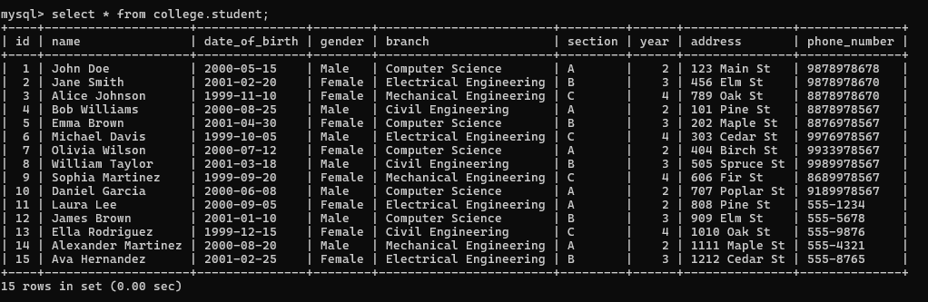

1. **Display only one student data record with any given phone number.**

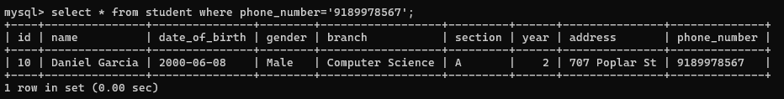

1. **Display students from any one branch**

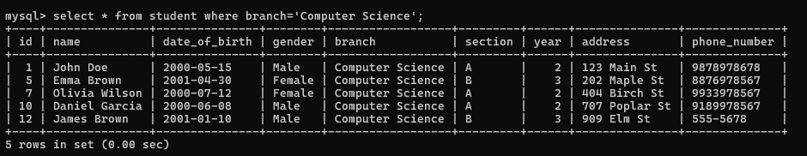

1. **Display students from any specific branch and specific section.**

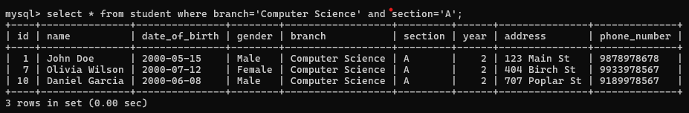

1. **Display girl students from the table.**

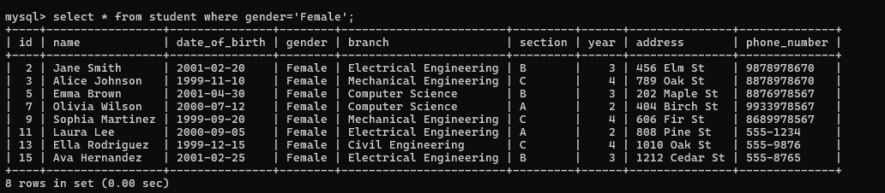

**12. Revoke all the permissions from the user ‘admin’.**



**13. Revoke only insert permission from the user ‘principal’.**



**14. Revoke update permission from the user ‘faculty’.**



**15. Revoke all the permissions from the user ‘student’.**

